CS 255 System Design Document Template

UML Diagrams

UML Use Case Diagram
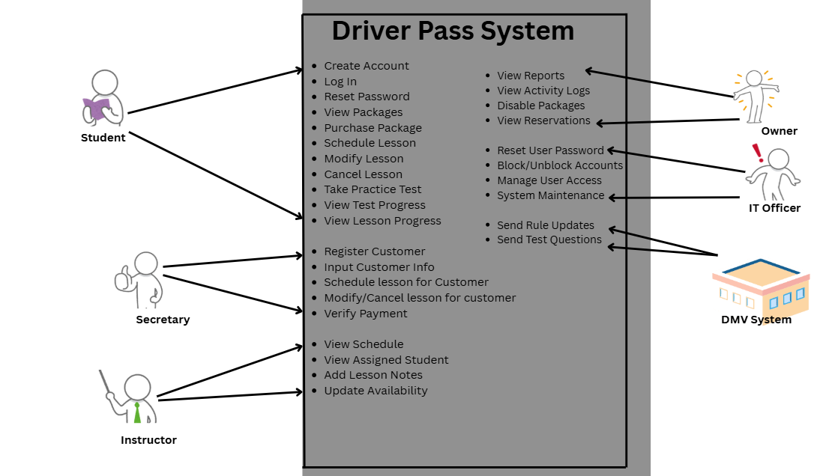

UML Activity Diagrams

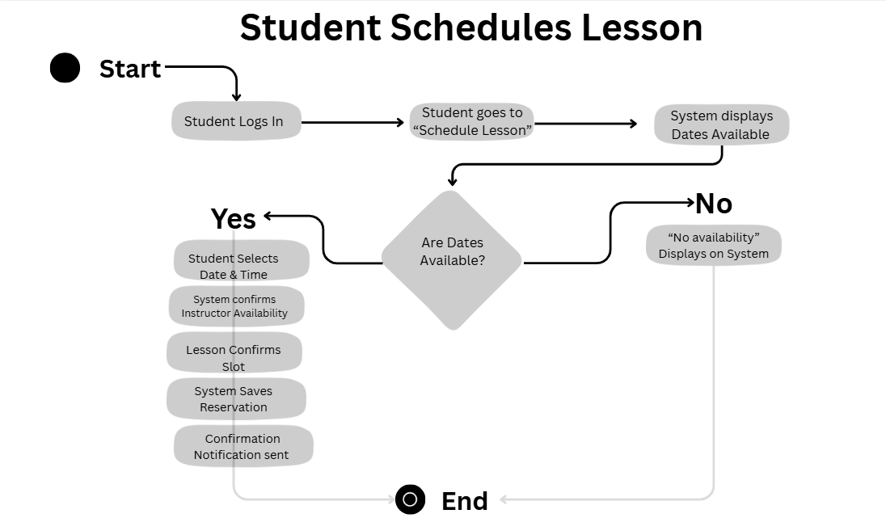
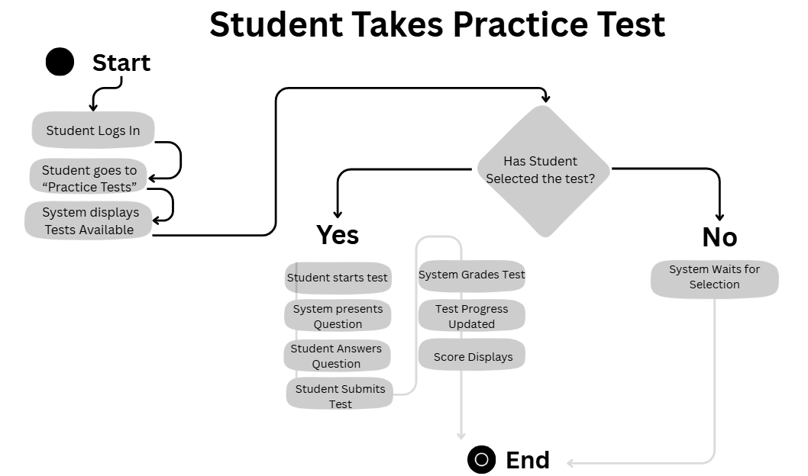

UML Sequence Diagram
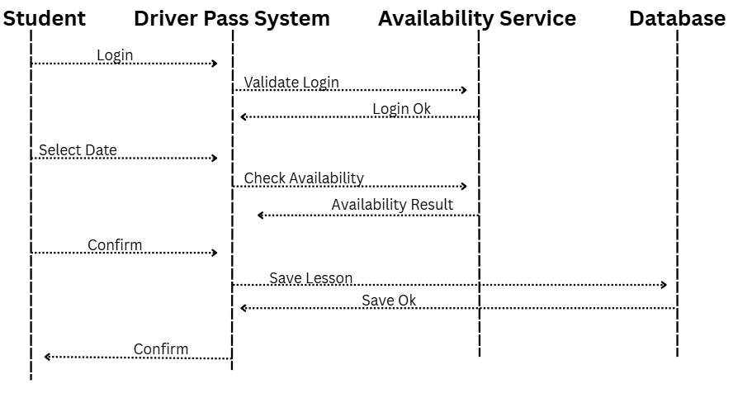

UML Class Diagram
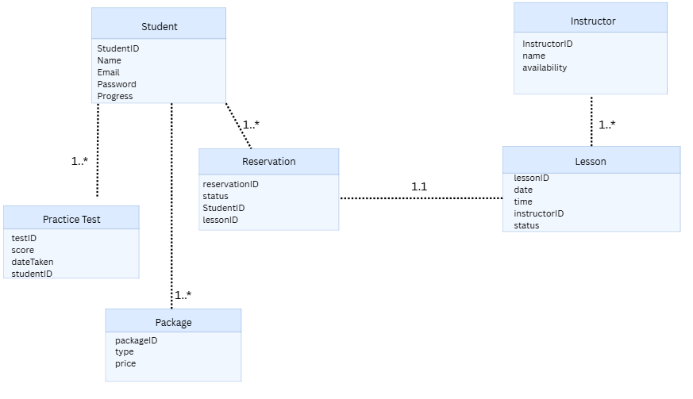

Technical Requirements
When I look back at the functional and nonfunctional requirements from the BRD, the technical needs for the DriverPass system become pretty straightforward. This system has to support students logging in, scheduling lessons, taking practice tests, and getting notifications, all while staying secure, reliable, and easy to use. Because of that, the setup needs to be a modern web-based application that works on the devices people already have. So on the user side, the only real “hardware requirement” is a computer, tablet, or smartphone with a current web browser like Chrome, Edge, Safari, or Firefox.
On the backend, the system needs to run on a cloud platform that can scale as more students and instructors use it. This includes virtual servers, load balancing, and enough storage to handle user accounts, reservations, instructor schedules, and practice test results. A relational database is necessary to keep all of that organized, and it needs to be secured with encryption and role-based access so only the right people can see or update sensitive information.
Since scheduling and notifications are a big part of the system, it also needs tools for managing instructor availability, sending confirmation emails or texts, and handling real-time updates. The whole application has to use HTTPS and SSL/TLS to meet the security requirements, and the infrastructure should include regular backups, monitoring, and disaster-recovery options to meet the reliability and uptime expectations. Altogether, these technical pieces support everything the system is supposed to do while meeting the performance, security, and usability standards laid out in Project One.

